MAS9 INSTALLATION GUIDE
(ARO Cluster Creation)
- Prerequisites:

- Create Resource Group

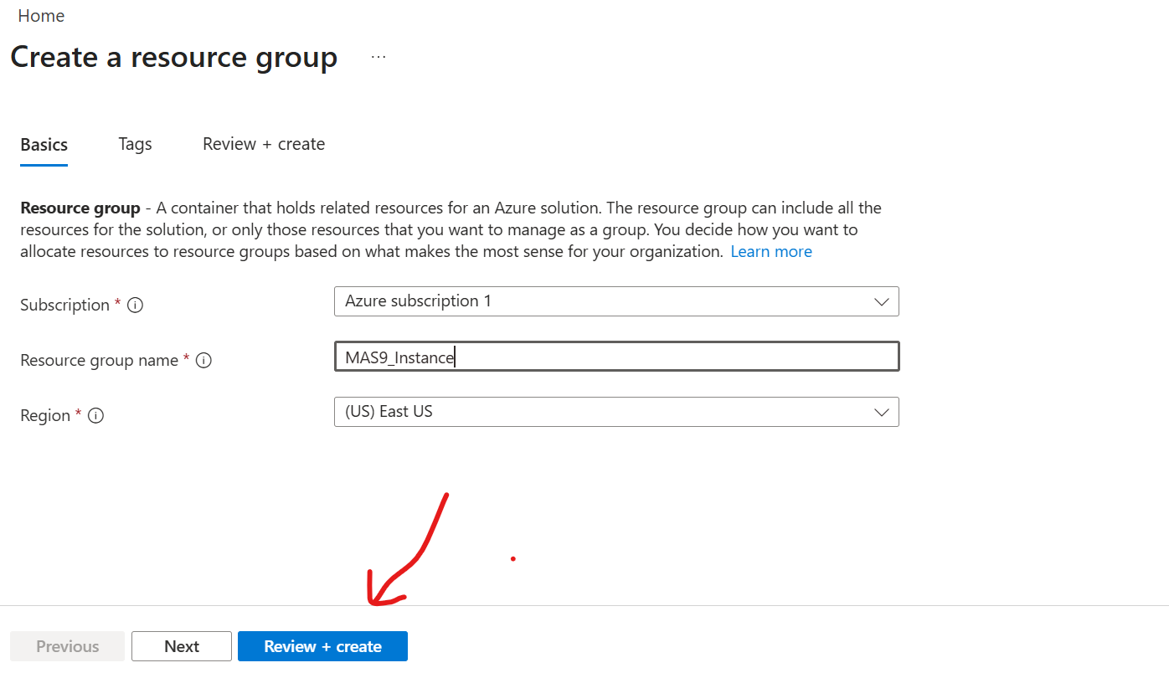
***Only take care of region in which you want to host VM’s (For this installation I have chosen Central India Region (Cost effective))
***I changed region after taking this screenshot

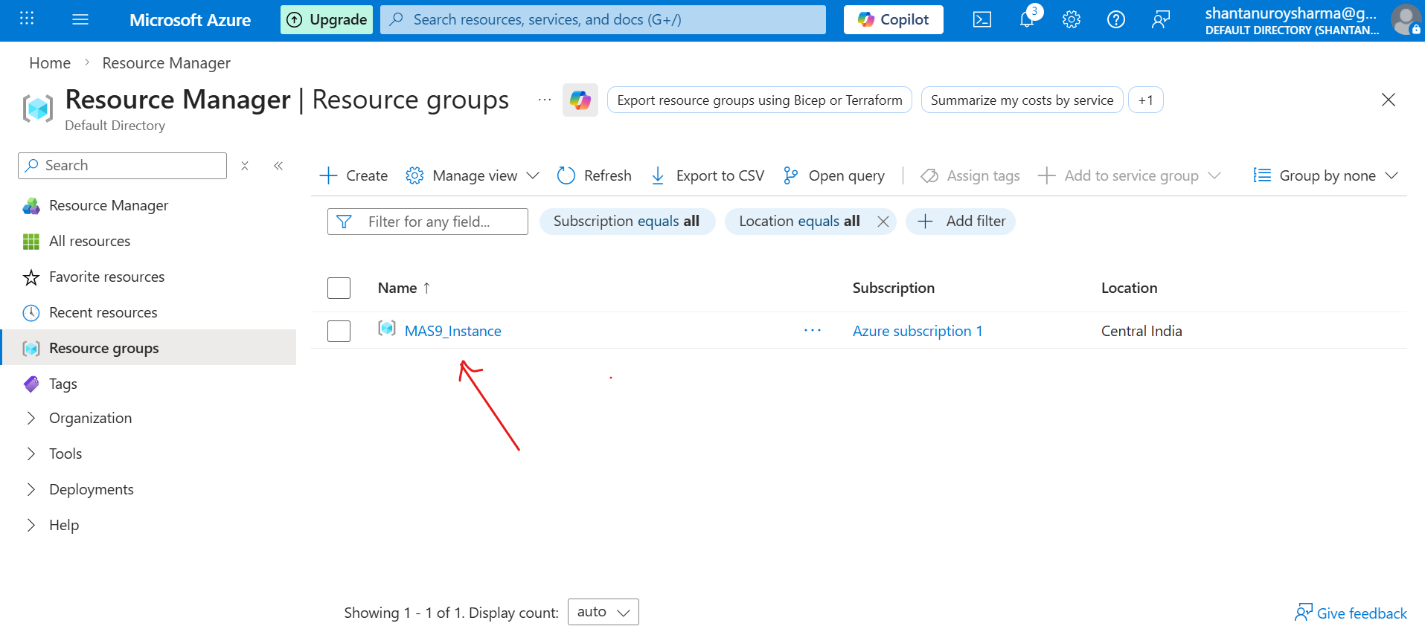
***Resource Group Created Successfully

- Create DNS (Setup Ingress Entry)
- You can go with Azure default DNS as well
- Create Service Principal
- You have to follow certain steps to create service principal
- Search for Microsoft Entra ID (Click and open)
- Click on App Registration under Manage
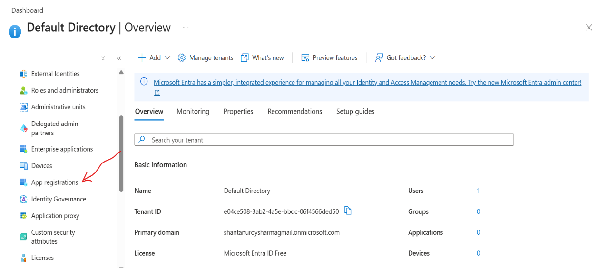

- Click on New Registration

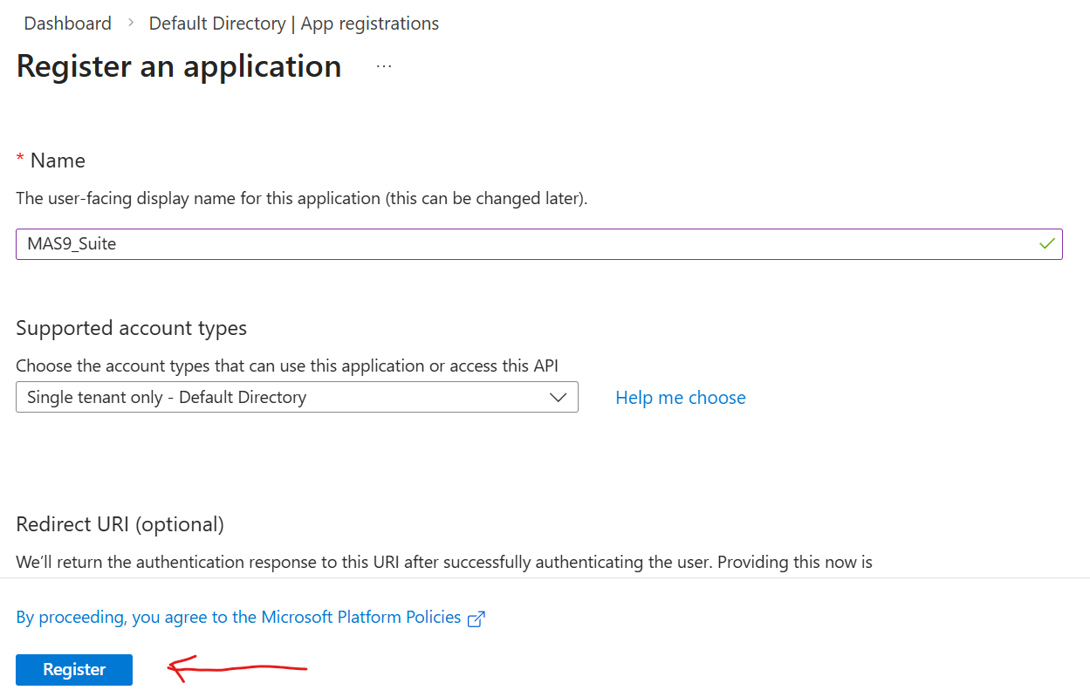
***Choose single tenant only – If you want to use this app under your org. only.
***Register application by following above screenshot.

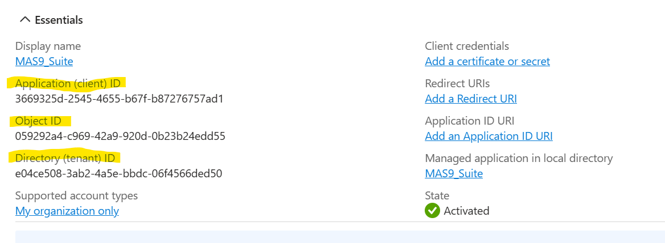
Application Client Id : Use for client Id env. variable
Object Id : For Internal Azure use only
Directory (tenant) ID : Use for tenant id env. variable

- Click on Certificates and secrets under Manage

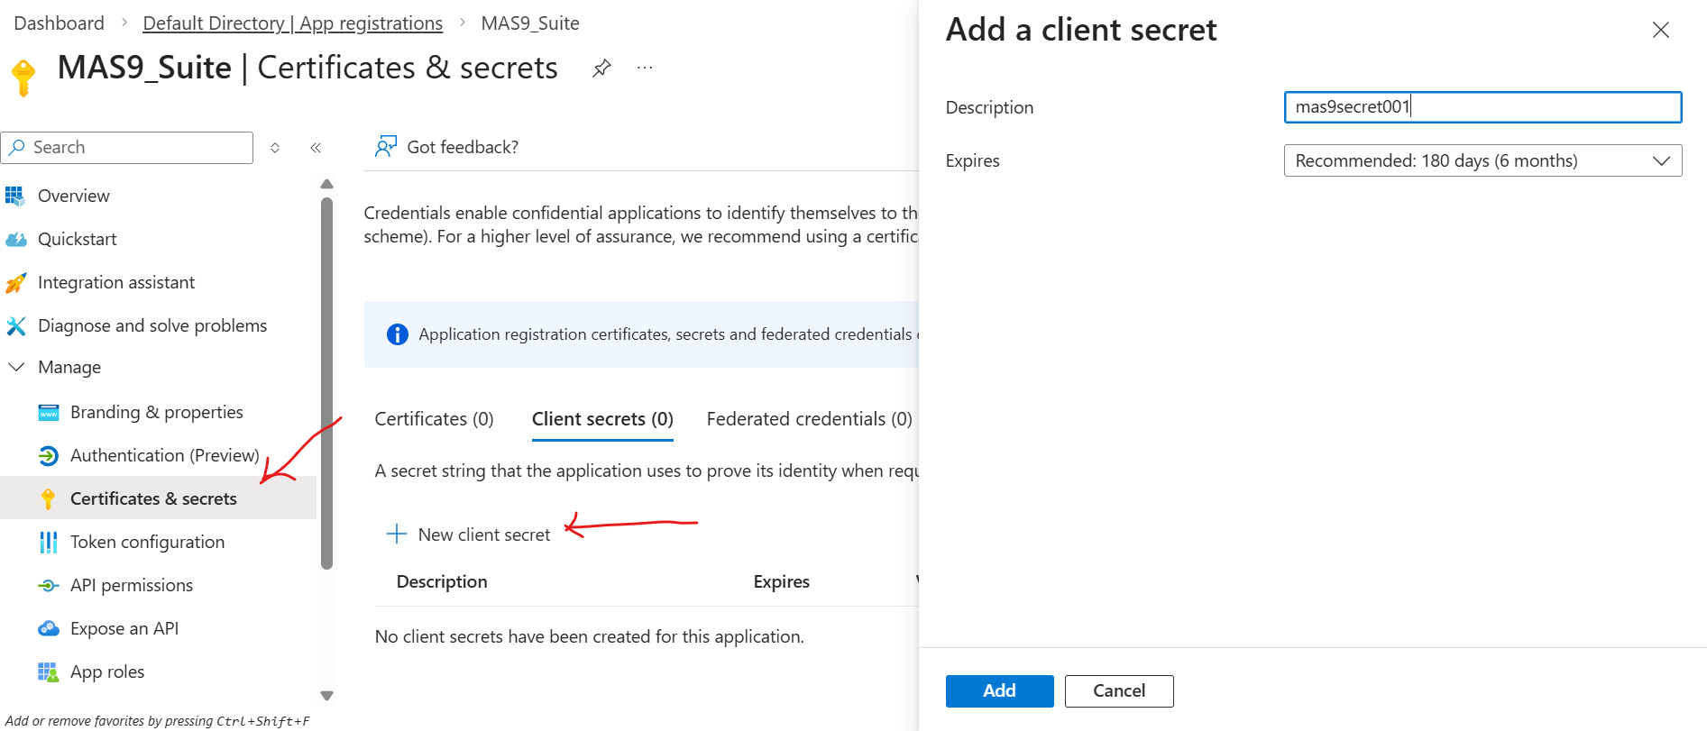
***Create new secret by clicking on add button above.

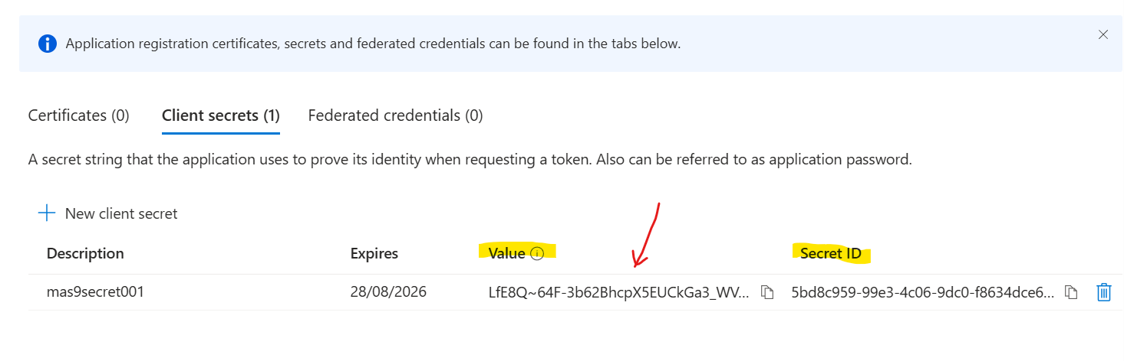
***Important - The secret Value will be displayed only once. Copy this value immediately and store it securely, as you cannot retrieve it later. This will be your client secret for MAS9 authentication.
- Open your created resource group there in left pane click on Access Control IAM.

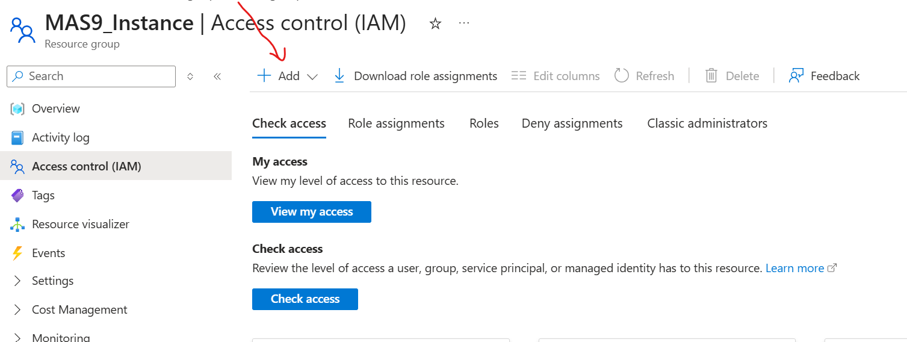
***Click on add Role assignment

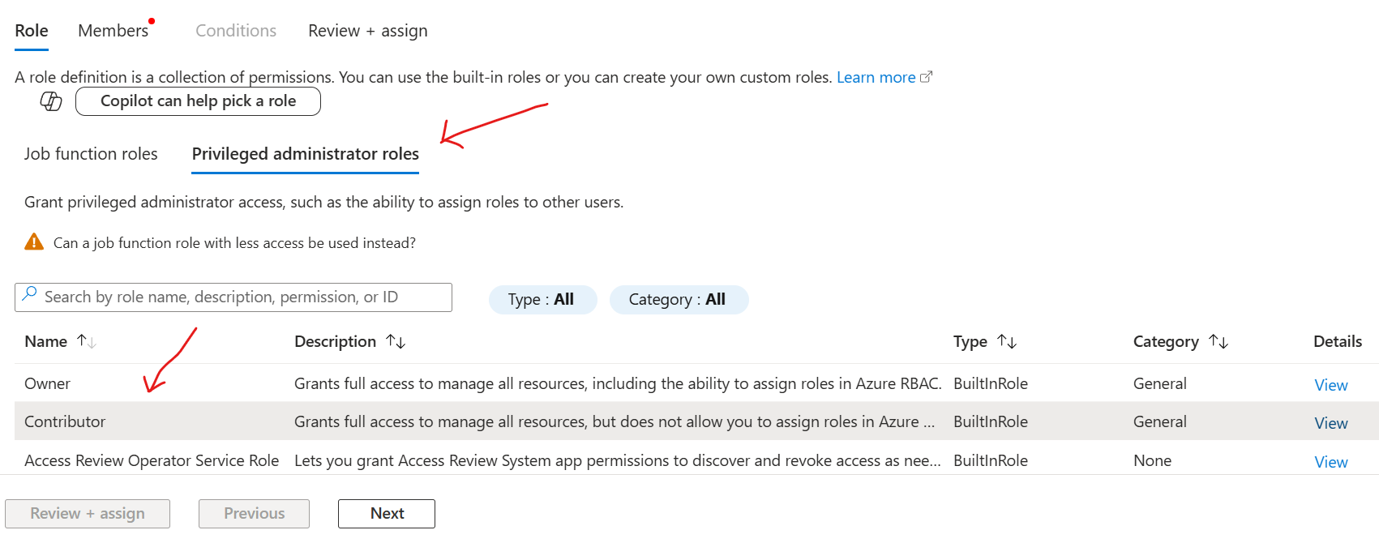
***Click on Privileged administrator roles and choose Contributor role.

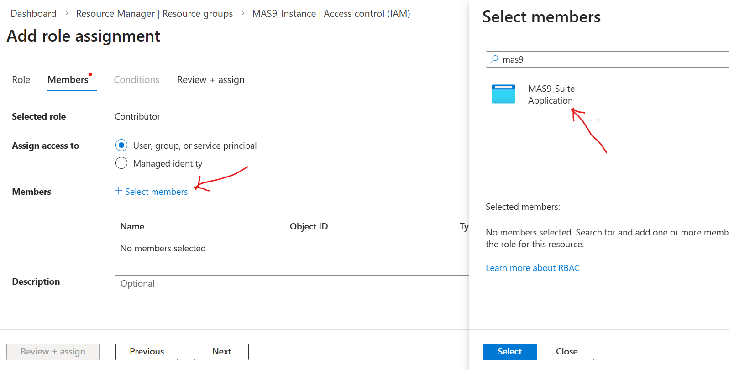
*** Click on Select members and choose your registered application.
Then Click on Review + assign

- In role assignment you can see your created Service Principal
- Require RedHat Pull Secret
- Go to console.redhat.com and click on downloads under Resources section in left pane. Scroll down and under token section you will get Pull Secret download option.
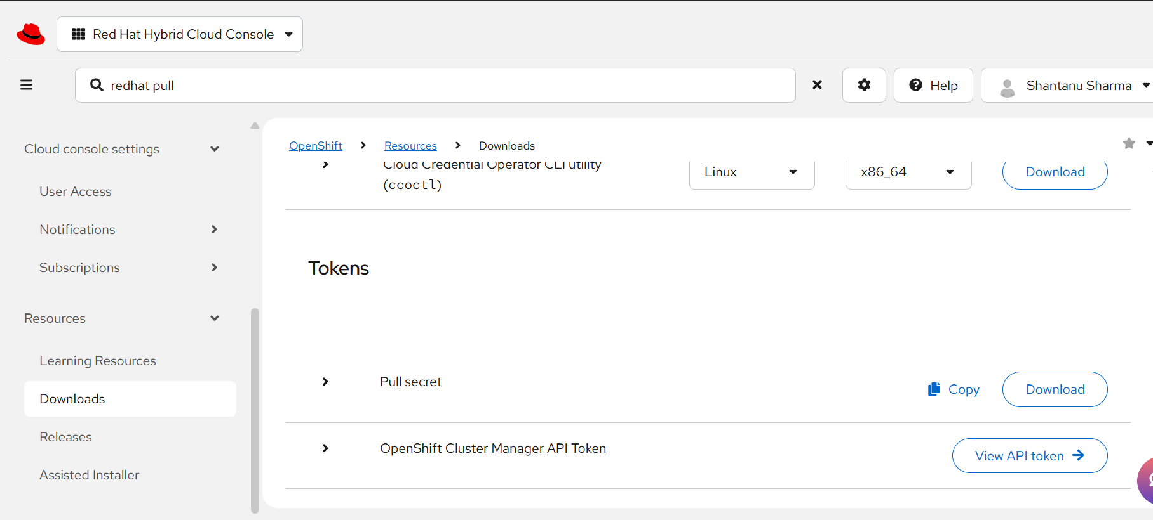

- Create Virtual Network (vNet)
- Search for Virtual network, Create on create and give resource group name and vNet name and also add subnets in in this vNet.

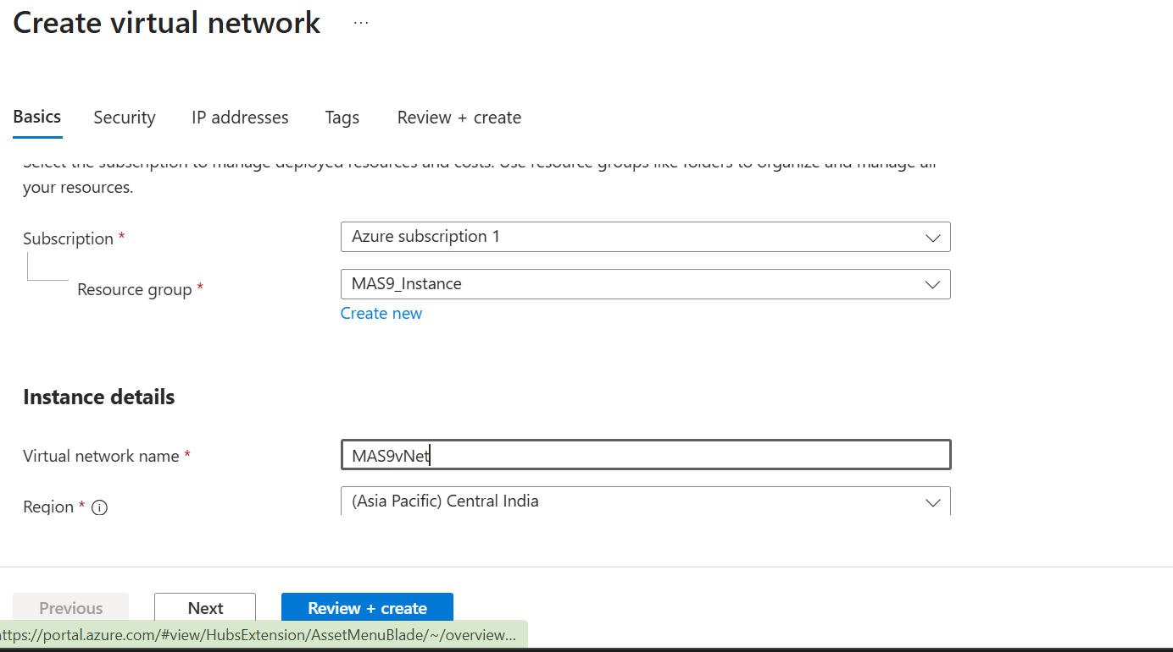

- Create Azure Redhat OpenShift cluster:

- Click on All Services in left pane -> Containers -> Click on Azure Redhat Openshift clusters

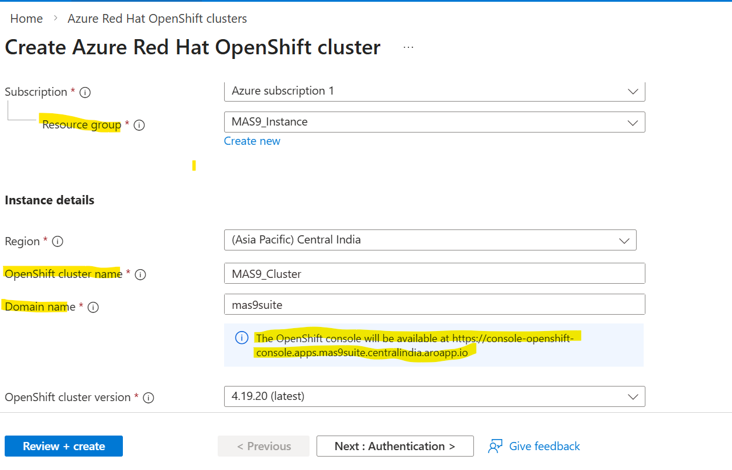
***Give Resource group name that we have created for MAS9, Same region as of resource group, If you will not give any DNS provider it will use default Openshift DNS
***Choose VM sizing as well for Master and Worker VM’s. I have chosen
Master VM size: 8vCPU, 32GB –> 3x
Worker VM size: 16vCPU, 64GB -> 3x
***This size will vary for production, You can change as per your requirement.
- Click on Authentication Section
- Choose service principal type as existing and provide client id and client secret.
- Paste Redhat Pull secret as well

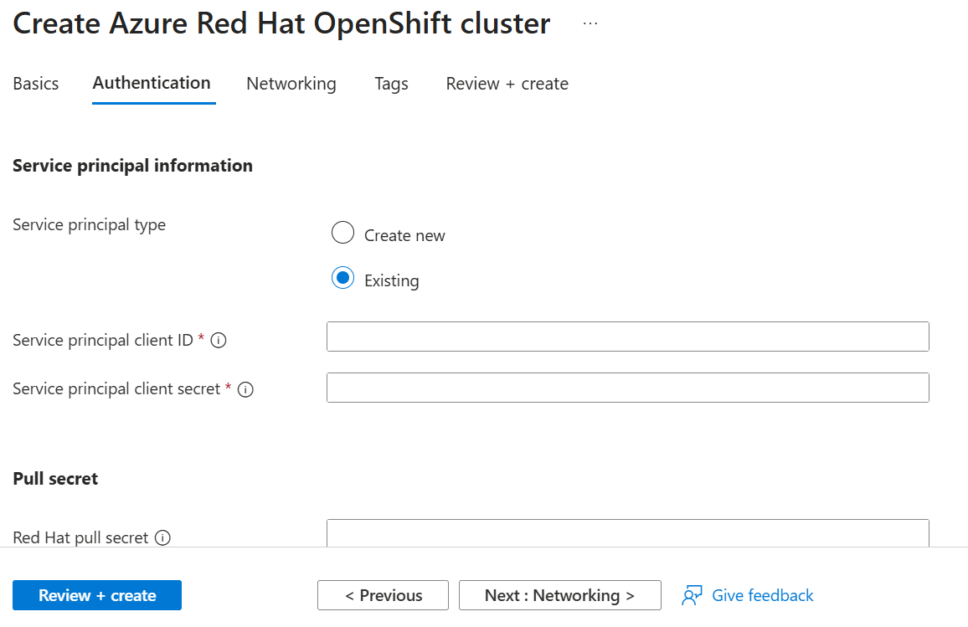
***You can get the client secret and id in Microsoft Entra Id-> App registration-> Certificates and Secrets
In client ID you have to paste Application Id.

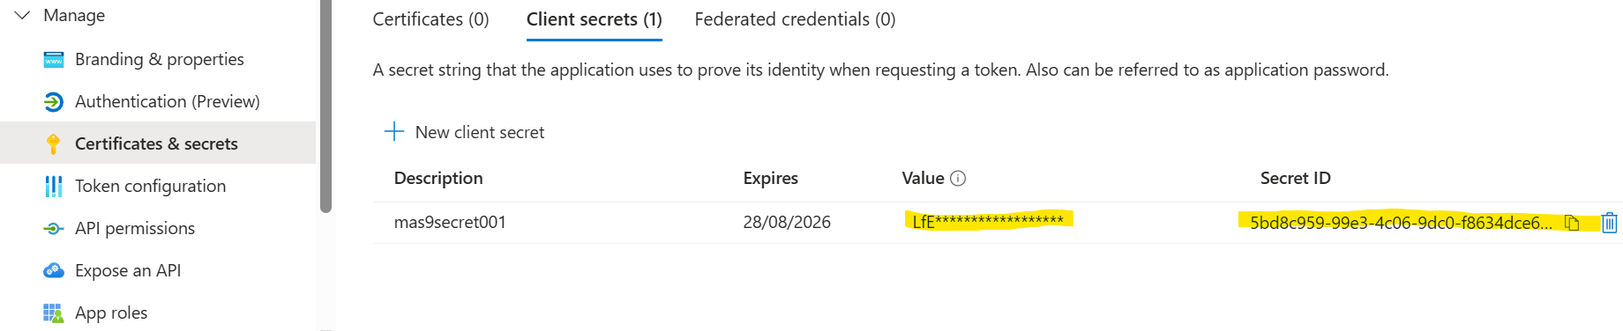
***As I told to paste the secret value for further use because it will disappear after first seen. But If you are not getting secret value then you can create a new client secret.

- Click on Networking Section
- Create new vNet(if not created) and create minimum 2 subnets as well for Master and Worker Nodes.

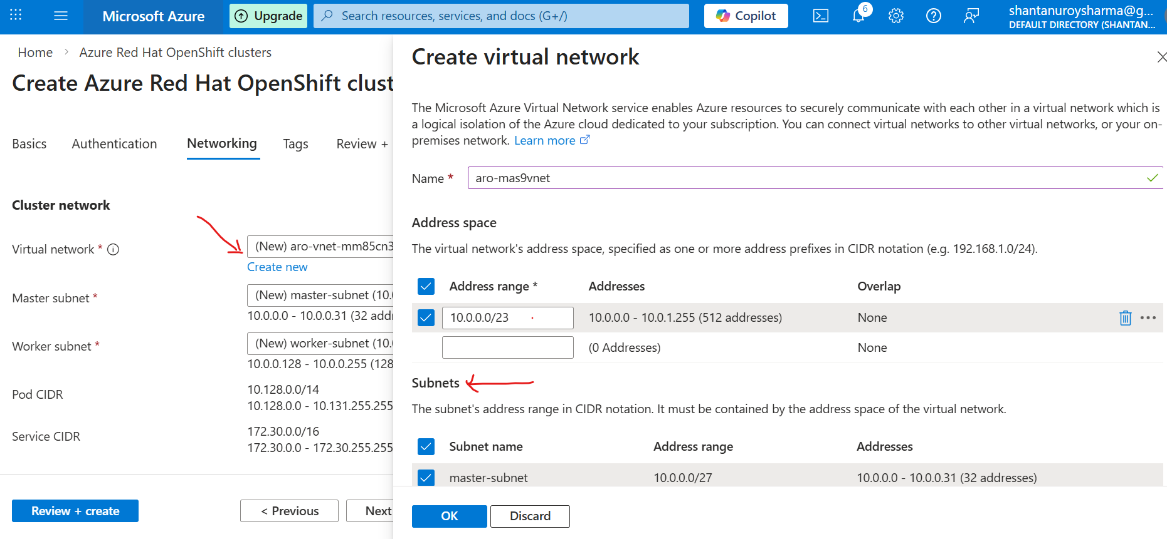
***In /23 CIDR notation, you can use 512 IP addresses in vNet.

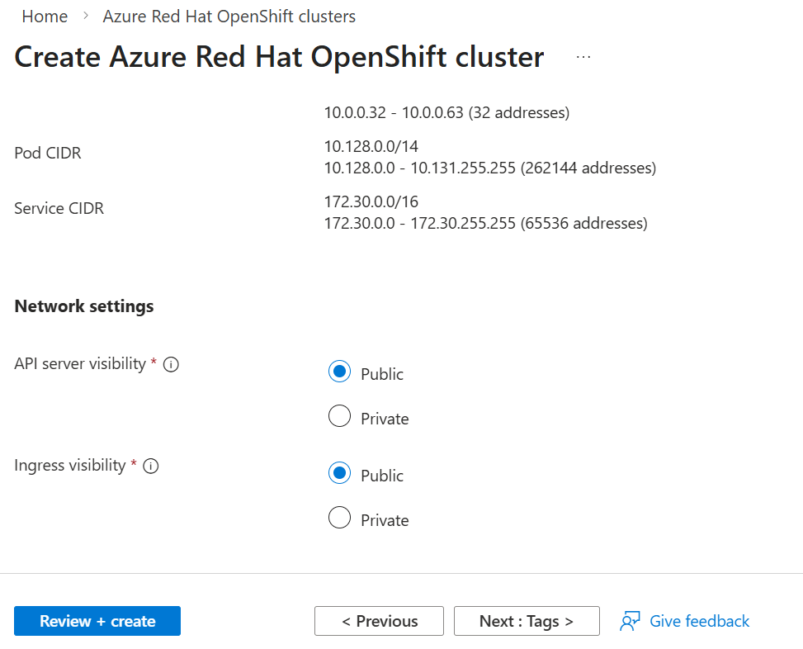
***Choose public only if you want to connect ARO cluster outside vNet e.g., Your local computer.
***Recommended to choose private and create Linux Jumpbox in same vNet.

- Add tags as well if required
- Click on Review+Create
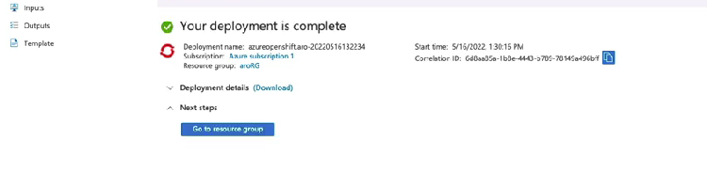
***After successful creation of ARO cluster you will see above screen.

- In left pane Output section you will get the credential to login into ARO cluster.

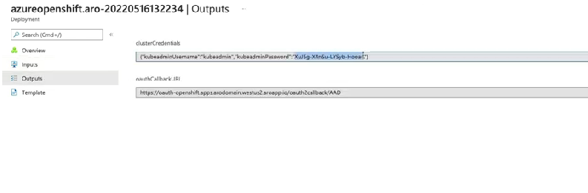
- In left pane Overview -> resource section -> click on ARO cluster application.
***Here you will get the cluster details and cluster console link as well.

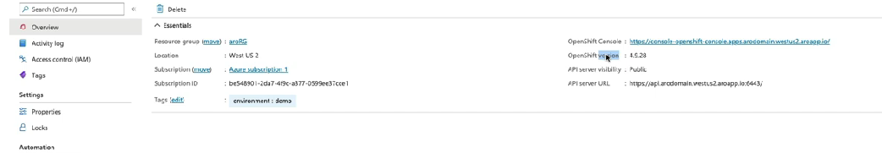

“Congratulations, now your ARO cluster is ready to use and you can connect it though your Linux JumpBox for MAS9 installation.”

